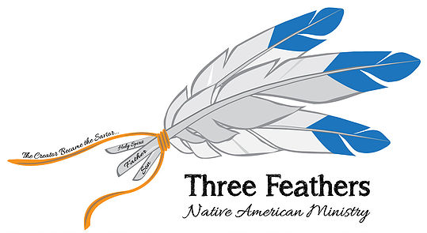
www.threefeathersministry.com robert@threefeathersministry.com Rev. Robert De Corah

Launched www.nativemi.org in Bemidgi, Minnesota on Thursday, August 9, 2018

Wow! It has been quite a year. Two years ago at United In Christ Conference where I launched Three Feathers Indian Ministry I met Rod Converse. He read my website where I said I wanted to mentor Indian Pastors and connect Indian Country. There are over 3000 native churches in the USA scattered throughout 567 Tribes on 326 reservations. Seventy per cent of Native Americans live in cities where they can find work. Rod said his company, Growth Zone, has the leading edge software and he would allow me to design the website. After praying and thinking I said it would be 3000 websites in one website. He said how is that possible? I said I do not know but we will get er done.

Well it is official and we are beginning to sign people up. I have been working about 40 to 50 hours a week on ministry from mentoring, developing the gold standard for native tribes, churches and ministries. Along with Andrew from Growth Zone and especially Sam Coulture my professional programmer, and Tonni Thunder Birds’ correcting all the tribal information, I can say praise God!

I have meetings with Vern Williams of Chapel Ministries to help plan and make decisions. Rod & Avis Converse also help strategize the website and the open doors that are coming in 2019 when I will travel more. I will be preaching, enrolling churches and ministries and visiting tribal offices to introduce them to a resource capable of searching for tribes 6 different ways.

When you find a tribe, all of the contact information is there with a map. You can click the map to navigate to the tribal office. You can click enlarge map and then select Nearby and select restaurants, gas stations, hotels or numerous other ways to view the tribe. I visited 4 tribes in August speaking to their tribal governmental people. The Menominee Tribal Administrator said I will instruct all of my tribal workers to immediately adopt your system.

In Wisconsin
I was able to visit with family and especially my mother who is battling Alzheimer’s. Like most reservations was able to help two families get rid of spirits in their homes in the Mighty name of Jesus Christ. I give thanks to the Lord for my two sisters who helped with seeing that 11 family members and friends prayed to accept Jesus Christ as Savior and had the joy of baptizing them.

In Illinois
I visited with life time friends, Dick and Dee Atkinson. Dee’s mother has become my oldest Partner in ministry contributing and taking up painting again to provide pictures. 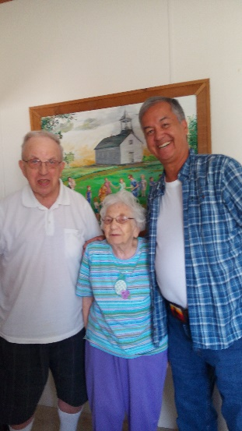 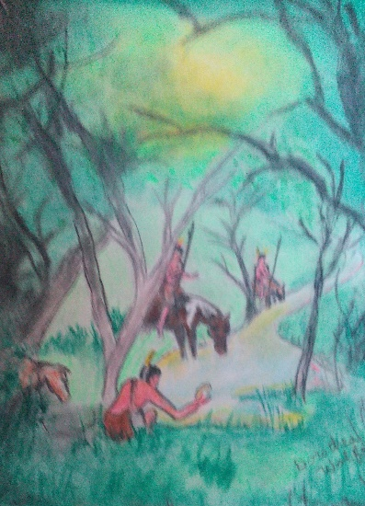 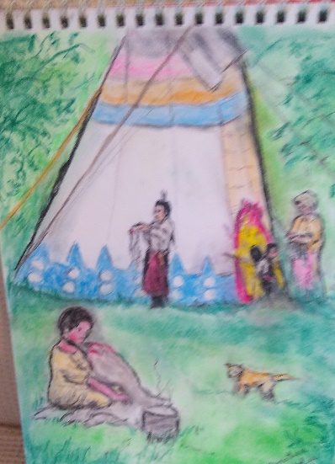
Dorothea M.Boyd Wolfe BD. Jan 9,1918. Married to Pastor James H. Boyd 46 years.
Remarried to Raymond W.Wolfe 28 years. She has authored “The Bad Man of the Hudson”,
”The Hog Money"{Mystery), Momma & Mr. Moody & Short Stories(Did all Illustrations.)
Dick & Dee would love all of the former Tabernacle friends to help Partner with them to help reach Indians for Jesus Christ sake! We will all stand before Jesus casting our crowns for the souls that were won and discipled.
My goal is to visit every reservation. Fifty per cent do not have a church on them. The Lord has led in buying a 23 foot trailer to use in ministry with many of the reservations being in the middle of no where. Please pray for the funds to pay for it, 2 inverter generators to power it, a satellite system to conduct ministry where I can sign up or live stream preaching as I go. It will also act as a link to have a phone that works since many reservations have little internet access on them.
If you would like to Partner with Ma Wolfe, 100 years, old and Dick and Dee please sign up on www.nativemi.org where it is easy to do so. I am your missionary. How can they believe unless someone goes? I have seen a Tribal Chief in the past give his heart to Jesus! God is able!
Robert De Corah
A Servant of Jesus Christ Who Is Lord!
Rev. Robert W. De Corah

